WEB PROGRAMMING

<html>

<head></head>

<body bgcolor="lightgreen"> //frame 1

<h1>

Mohandas college of Engineering & Technology

</h1>

</body>

</html>

<html>

<head><title></title></head>

<body bgcolor="lightyellow">

<h1>

NAVIGATION MENU //frame2

</h1>

<ul>

<li><a href="mca" target="_self">MCA</a></li>

<li><a href="MBA" target="_self">MBA</a></li>

<li><a href="M.tech" target="_self">M.TECH</a></li>

<li><a href="B.TECH" target="_self">B.TECH</a></li>

<ul style="list-style-type:circle;">

<li><a href="CSE" target="_self">CSE</a></li>

<li><a href="EEE" target="_self">EEE</a></li>

<li><a href="BT" target="_self">BT</a></li>

<li><a href="ece" target="_self">ECE</a></li>

<li><a href="CE" target="_self">CE</a></li>

</ul>

</body>

</html>

<html>

<head><title></title></head>

<body bgcolor="lightblue">

<p >Mohandas college engineering and technology(mcet) is an engineering and technology college located at the village anad,

trivandrum district, kerala india.the college,which is affliated to the KTU,was established in 2002.Mohandas college is a

project of the mohandas group of companies and is manged by the VN GANGADHARA PANIKKER MEMRIAL TRUST. the college has recieved

ISO 9001:2008 certification

</p>

</body> //frame 3

</html>

<html>

<head>

<title></title>

</head>

<frameset rows="35%,65%" >

<frame src="head.html">

<frameset cols="30%,70%">

<frame src="lparq.html"> main frame

<frame src="para .html">

</frameset>

<body>

</body>

</html>

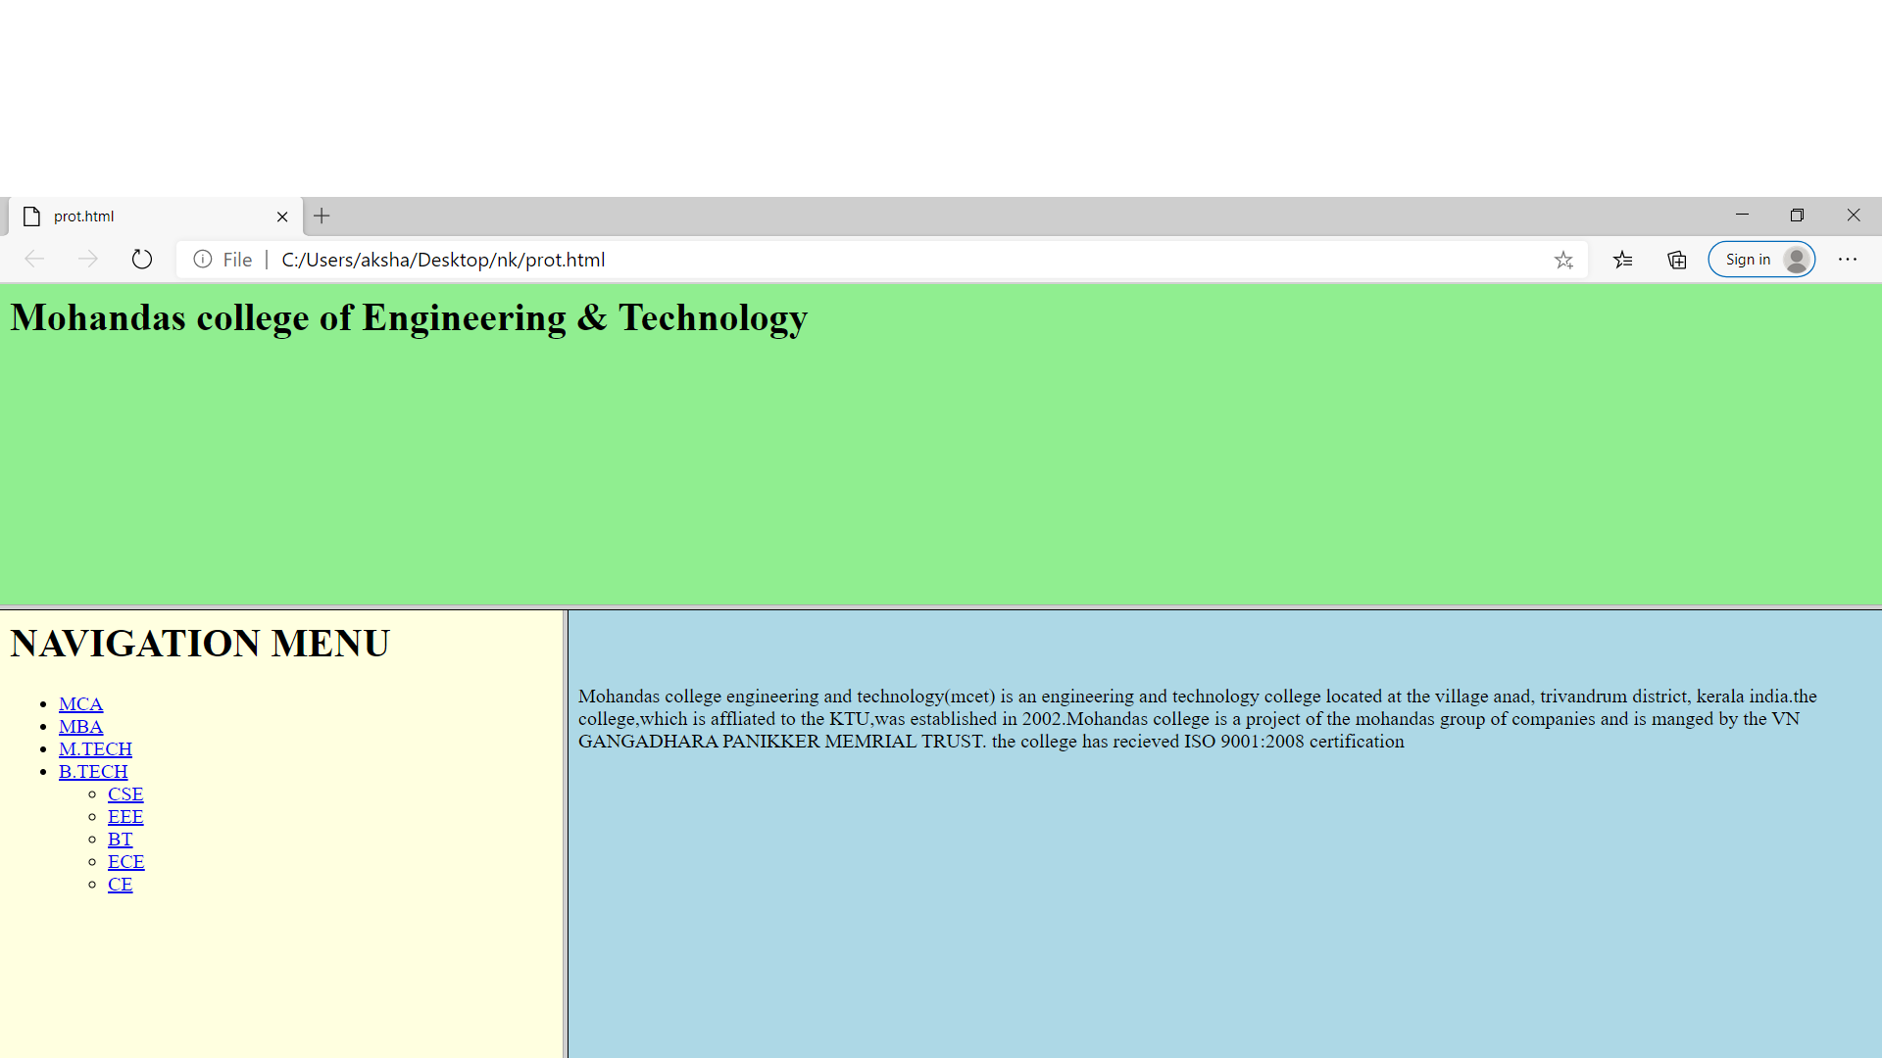

2

<html align="center">

<head></head>

<body>

<style>

.border

{

padding: 20px;

margin-left: 40%;

margin-right: 40%;

border-radius: 4px;

border: 3px solid black;

}

</style>

<br>

<form class="border" action=""method="post">

<table cellspacing="7px" cellpadding="7%"; align="center">

<tr><h2 align="center"> Employee Details</h2></tr>

<tr>

<td>ID</td>

<td><input type="text"></td></tr>

<tr>

<td>Name</td>

<td><input type="text"></td></tr>

<tr>

<td>Gender</td>

<td><input type="radio" name="g">Male

<input type="radio" name="g">Female </td></tr>

<tr>

<td>Designation</td>

<td><select name = "dropdown">

<option value = "software engineer" selected>software engineer</option>

<option value = "debugger">debugger</option>

</select></td></tr>

<tr>

<td>Salary</td>

<td><input type="text"></td></tr>

</table>

<tr> <input type="button" value="Submit" align="center"></tr>

</form>

</body>

</html>

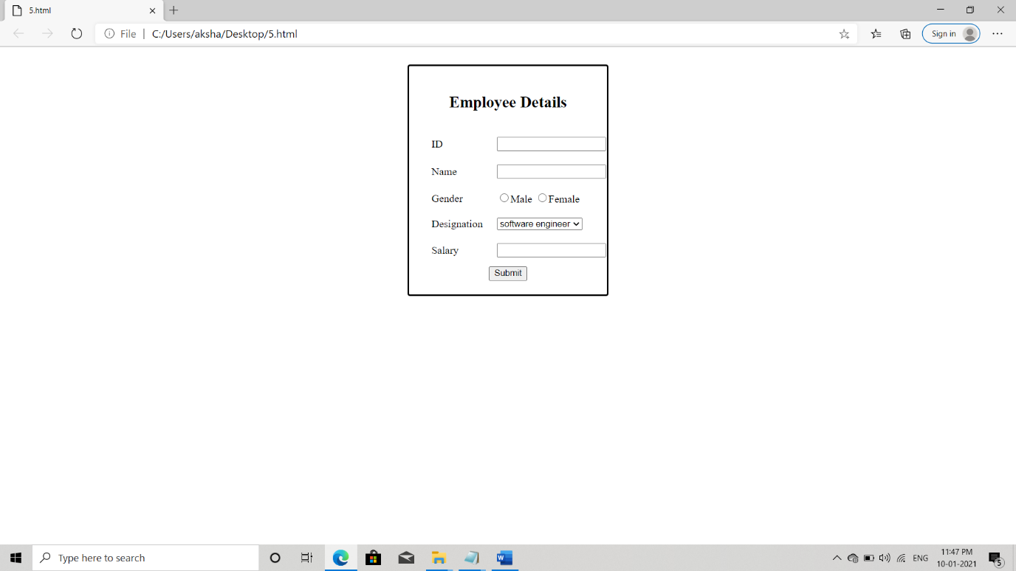

3

<html lang="en">

<head>

<link rel="stylesheet" href="bb12.css">

<title>time loop</title>

</head>

<body>

<header>

<h2>time loop</h2>

</header>

<h3 align="center">A pocket universe or bubble universe is a concept in inflationary theory, proposed by Alan Guth. It defines a realm like the one that contains the observable universe as only one of many inflationary zones</h3>

<section align="center">

<div id="menu">

<ul>

<li><a href="#">bubble universe</a></li>

<li><a href="#">pocket universe</a></li>

<li><a href="#">pocket dimension</a></li>

</ul>

</div>

</section>

</body>

</html>

Css

* {

box-sizing: border-box;

}

body {

background-color:lightblue;

color: blue;

}

h2 {

padding: 50px;

font-family: Arial,helvetica, sans-serif;

text-align: center;

font-size: 50px;

color: magenta;

text-decoration-line:underline;

}

h3 {

padding: 20px;

font-family: "lucida cnsole", "courier New", monospace;

text-align: center;

font-size: 25px;

color: tan;

}

menu

{

background-color:greenyellow;

color: white;

padding: 180px;

font-size: 20px;

border: none;

cursor: disk;

}

#menu ul li a

{

color: green;

font-family: fantasy;

font-size:x-large;

text-align: center;

list-style-type: none;

}

